**Checks and Questions ISATPhone-FleetPhone**

**Questions**

* What is your mobile’s ICCID or MSISDN?
* What is the software version used (Inmarsat Firmware and device Firmware)?
* In which country or region are you located?
* Is your antenna signal strong and stable? How many bars are there?
* Did the terminal work before?
* Since when did the service stop working?
* What is the error code or error message on the screen or during connection to data/SkyFile?
* Is the current GPS Position up-to-date*?*
* *If a red planet is displayed on the screen, it means that the GPS position is not valid and that the phone is still searching.*
* For FleetPhone only: What is the terminal manufacturer and model (Oceana 400, Oceana 800, terra 800)?
  + *For the phone’s firmware, it is found in Settings > About.*
* Are you using a username and password for the connection? If yes, please confirm.
* *The username and password is the same, “INMARSAT” (all in upper case).*
* If a docking station is used: Please advise the model and Firmware of the docking station.
  + *Firmware can be found in the* ***About*** *section of the software, given by the manufacturer of the docking (Mainly Beam systems).*
* Please advise if the handset used is a Marlink one.

**Checks**

* Software info:
  + In case the IsatPhone software version is on the Inmarsat website: [www.inmarsat.com/support](http://www.inmarsat.com/support).
  + In case of FleetPhone or DS, the customer needs to use a tool called Falcon, which is available at [www.beamcommunications.com](http://www.beamcommunications.com).
* Check the card status in **BSS**, **The Source**.
* Check call records in **The Source**.
* Check the GPS position with the customer.
* Check the antenna signal with the customer.
* In case of any SkyFile issue with IsatPhone/ FleetPhone:
  + If possible, for SkyFile communications, advise if a modem is directly used or if they are using the port com.
  + In the Device Manager, check the status of the com port related to the IsatPhone (Can you see a yellow question mark (?) or not?).
  + *The Device Manager is the screen where all the ports are referenced. To go there, you need to right-click on the Computer icon, then click on ‘Manage’ and finally ‘Device manager.’*

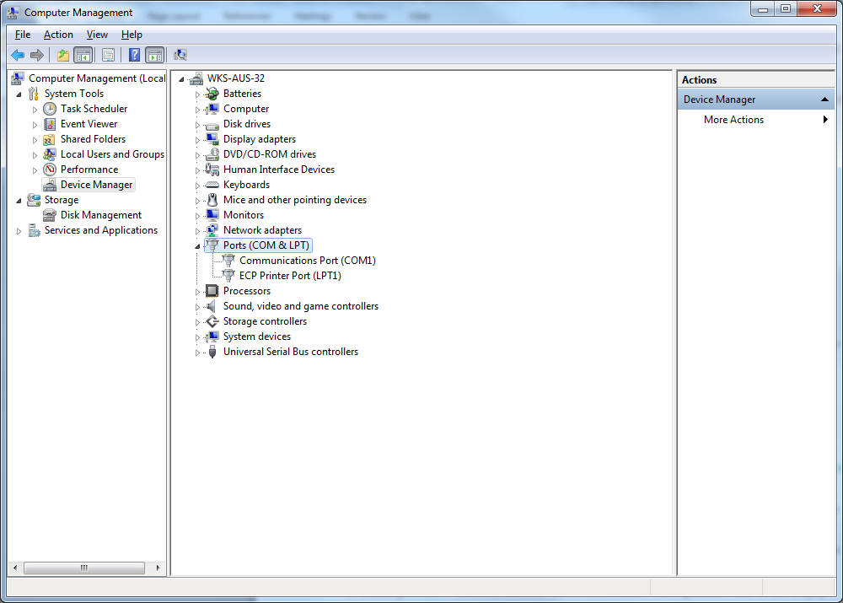

* + If also possible, check if the AT command (“AT&FE0&D2”) is implemented in the modem configuration (Data only).
* How/where exactly can this be checked?

1. Go to Control Panel > Phones and Modem.
2. Then, for the modem part, select *Isatphone Pro1.0 Modem*, then click on ‘Properties,’ and in the **Advance** Menu, check for the line “Extra Initialization commands.”

* For SkyFile use and if no docking station is used, check the AT command in the second line of the modem option.
* How/where exactly can this be checked?

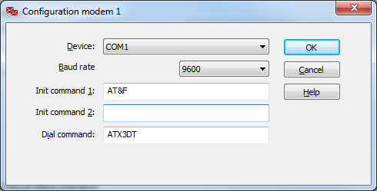In the SkyFile account and dial parameters in the modem options as shown below:

* If the docking station is used, the second line of the modem configuration has to be empty.